DATE | COPY | IMAGE
Share ASAP  Announcement Post | Facebook/LinkedIn/Instagram:  On July 22, join the @World Federation of Neurology and the @International Headache Society as we share the painful truth about #migraine.  This year, World Brain Day is dedicated to raising awareness about the most common brain disease in the world—migraine. Migraine affects one in seven people and, together with other headache disorders, is one of the leading causes of disability worldwide. Despite its pervasive impact, migraine continues to be vastly under-recognized, underdiagnosed and under-treated.  Stay tuned for more information on how to help us stand beside the more than one billion people living with migraine worldwide. #thepainfultruth #worldbrainday #migraine  https://www.wfneurology.org/world-brain-day-2019  Twitter:  On July 22, join the @wfneurology and @ihs_official as we share #thepainfultruth about #migraine, the most common brain disease in the world. #worldbrainday https://www.wfneurology.org/world-brain-day-2019 | 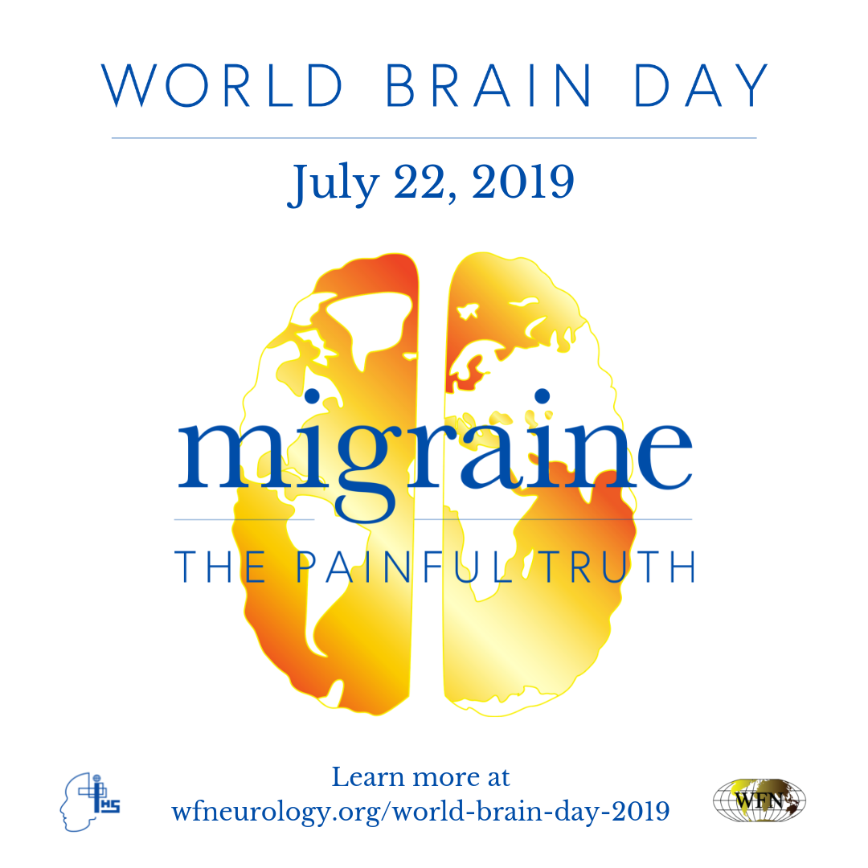
Wednesday, June 10 | Facebook/LinkedIn/Instagram:  Migraine is the most common brain disease in the world, affecting 1 in 7 people worldwide. This year, World Brain Day is dedicated to sharing the painful truth about migraine. Join us to raise awareness by sharing your painful truth about migraine in the comments below. #ThePainfulTruth #WorldBrainDay  https://www.wfneurology.org/world-brain-day-2019  Twitter:  #Migraine is the most common brain disease, affecting 1 in 7 people worldwide. This year, #WorldBrainDay is dedicated to sharing #thepainfultruth about migraine. Join us to raise awareness by sharing your painful truth about migraine in the comments below. https://www.wfneurology.org/world-brain-day-2019 | 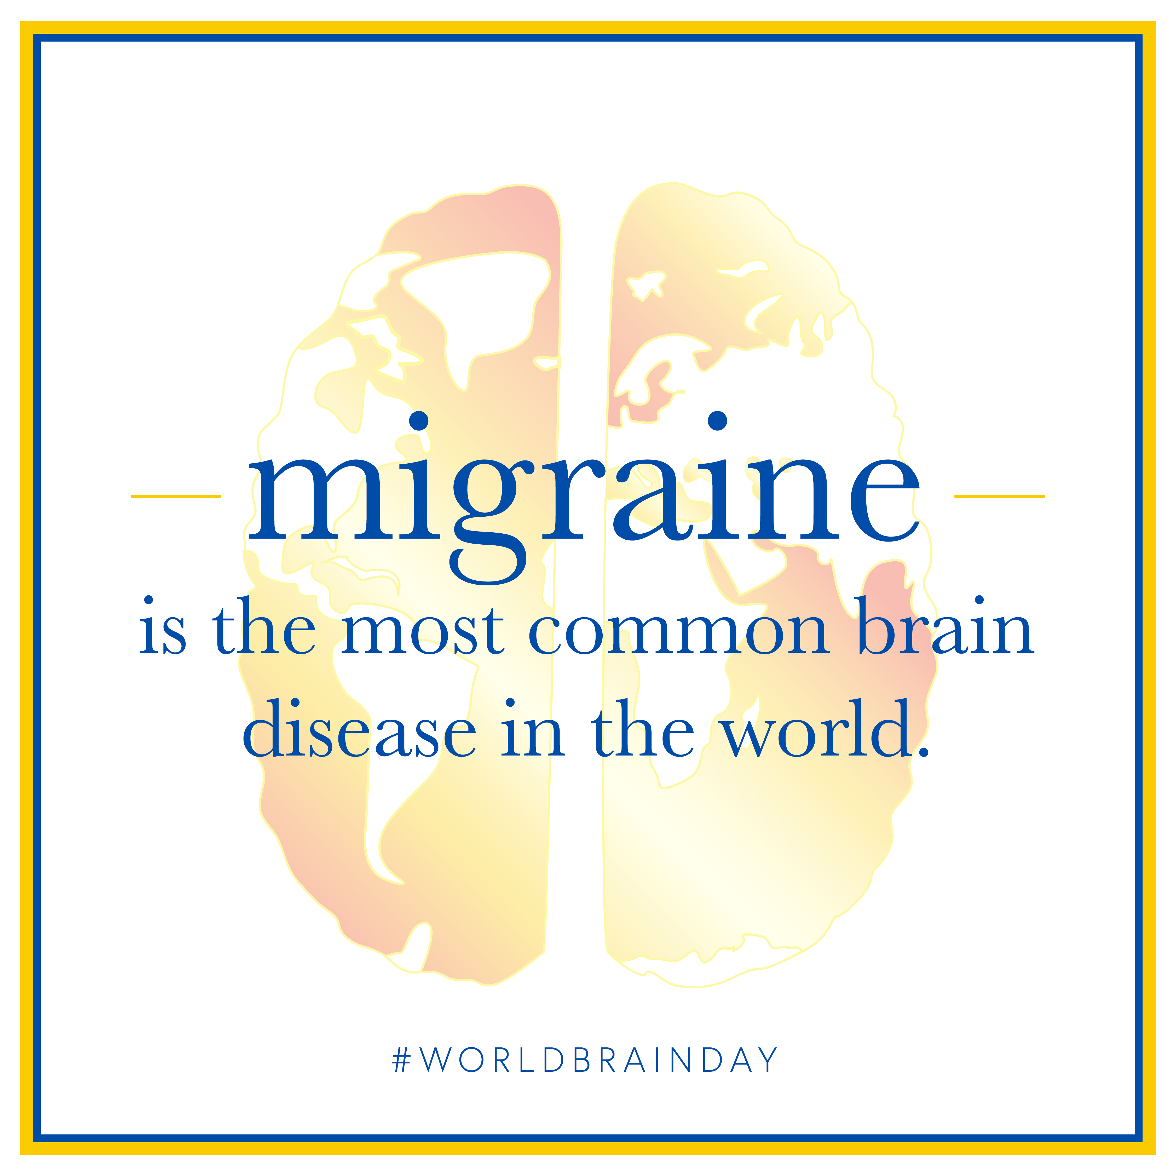
Wednesday, June 17 | Facebook/LinkedIn/Instagram:  Migraine is one of the leading causes of disability worldwide. It can severely impact every aspect of a person’s life—family, relationships, work and more. Join us in raising awareness around this disease by sharing the painful truth about migraine. How has migraine impacted your life? Tell us below in the comments. #worldbrainday #thepainfultruth  [link] https://www.wfneurology.org/world-brain-day-2019  Twitter:  #Migraine is one of the leading causes of disability worldwide, impacting every aspect of a person’s life—family, relationships, work and more. This #WorldBrainDay, let’s raise awareness by sharing #thepainfultruth. How has migraine impacted your life? https://www.wfneurology.org/world-brain-day-2019 | 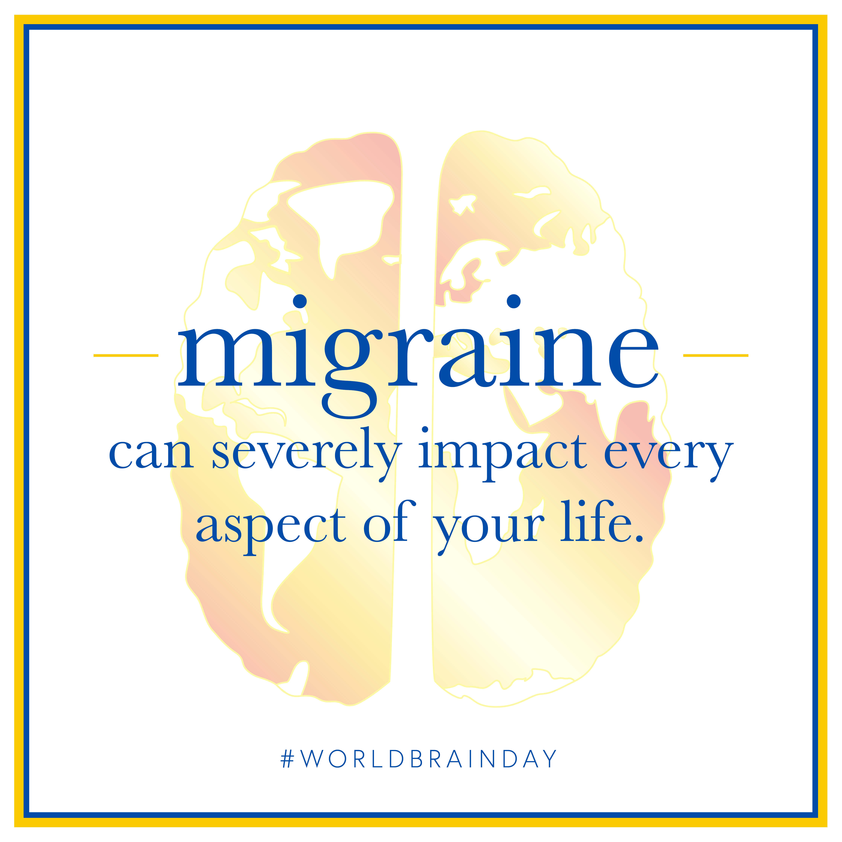
Monday, June 24  Webinar Announcement | Facebook/LinkedIn/Instagram:  For World Brain Day on July 22, we invite you to attend a webinar designed to raise awareness around the most common brain disease in the world—migraine. With a list of panelists that includes David Dodick, MD, FAHS, Chair of @American Migraine Foundation; Tissa Wijeratne, World Brain Day Chair and professor at @the University of Melbourne; Wolfgang Grisold, Secretary General of the @World Federation of Neurology; William Carroll, World Federation of Neurology President; and Elaine Jones, @American Academy of Neurology board member, participants will learn about the global impact of migraine. Sign up here:  https://register.gotowebinar.com/register/4427363188472679693  Twitter:  For #WorldBrainDay July 22, attend a webinar to raise awareness around the most common brain disease—migraine. With panelists @DavidDodick, @combatstrokeSL, @WGrisold, William Carroll, and @Lnyjri, discover the global impact of migraine. Sign up here: https://register.gotowebinar.com/register/4427363188472679693
Monday, July 1 | Facebook/LinkedIn/Instagram:  Even though migraine affects one in seven people worldwide, it does not get the attention it deserves. This World Brain Day, join us to bring more attention to this disabling disease by attending our webinar on July 22. Register on our website now. #WorldBrainDay #ThePainfulTruth  https://register.gotowebinar.com/register/4427363188472679693  Twitter:  #Migraine affects 1 in 7 people worldwide, but does not get the attention it deserves. This #WorldBrainDay, join us to bring more attention to this disabling disease by attending our #webinar on July 22. Register now. #ThePainfulTruth  https://register.gotowebinar.com/register/4427363188472679693 | 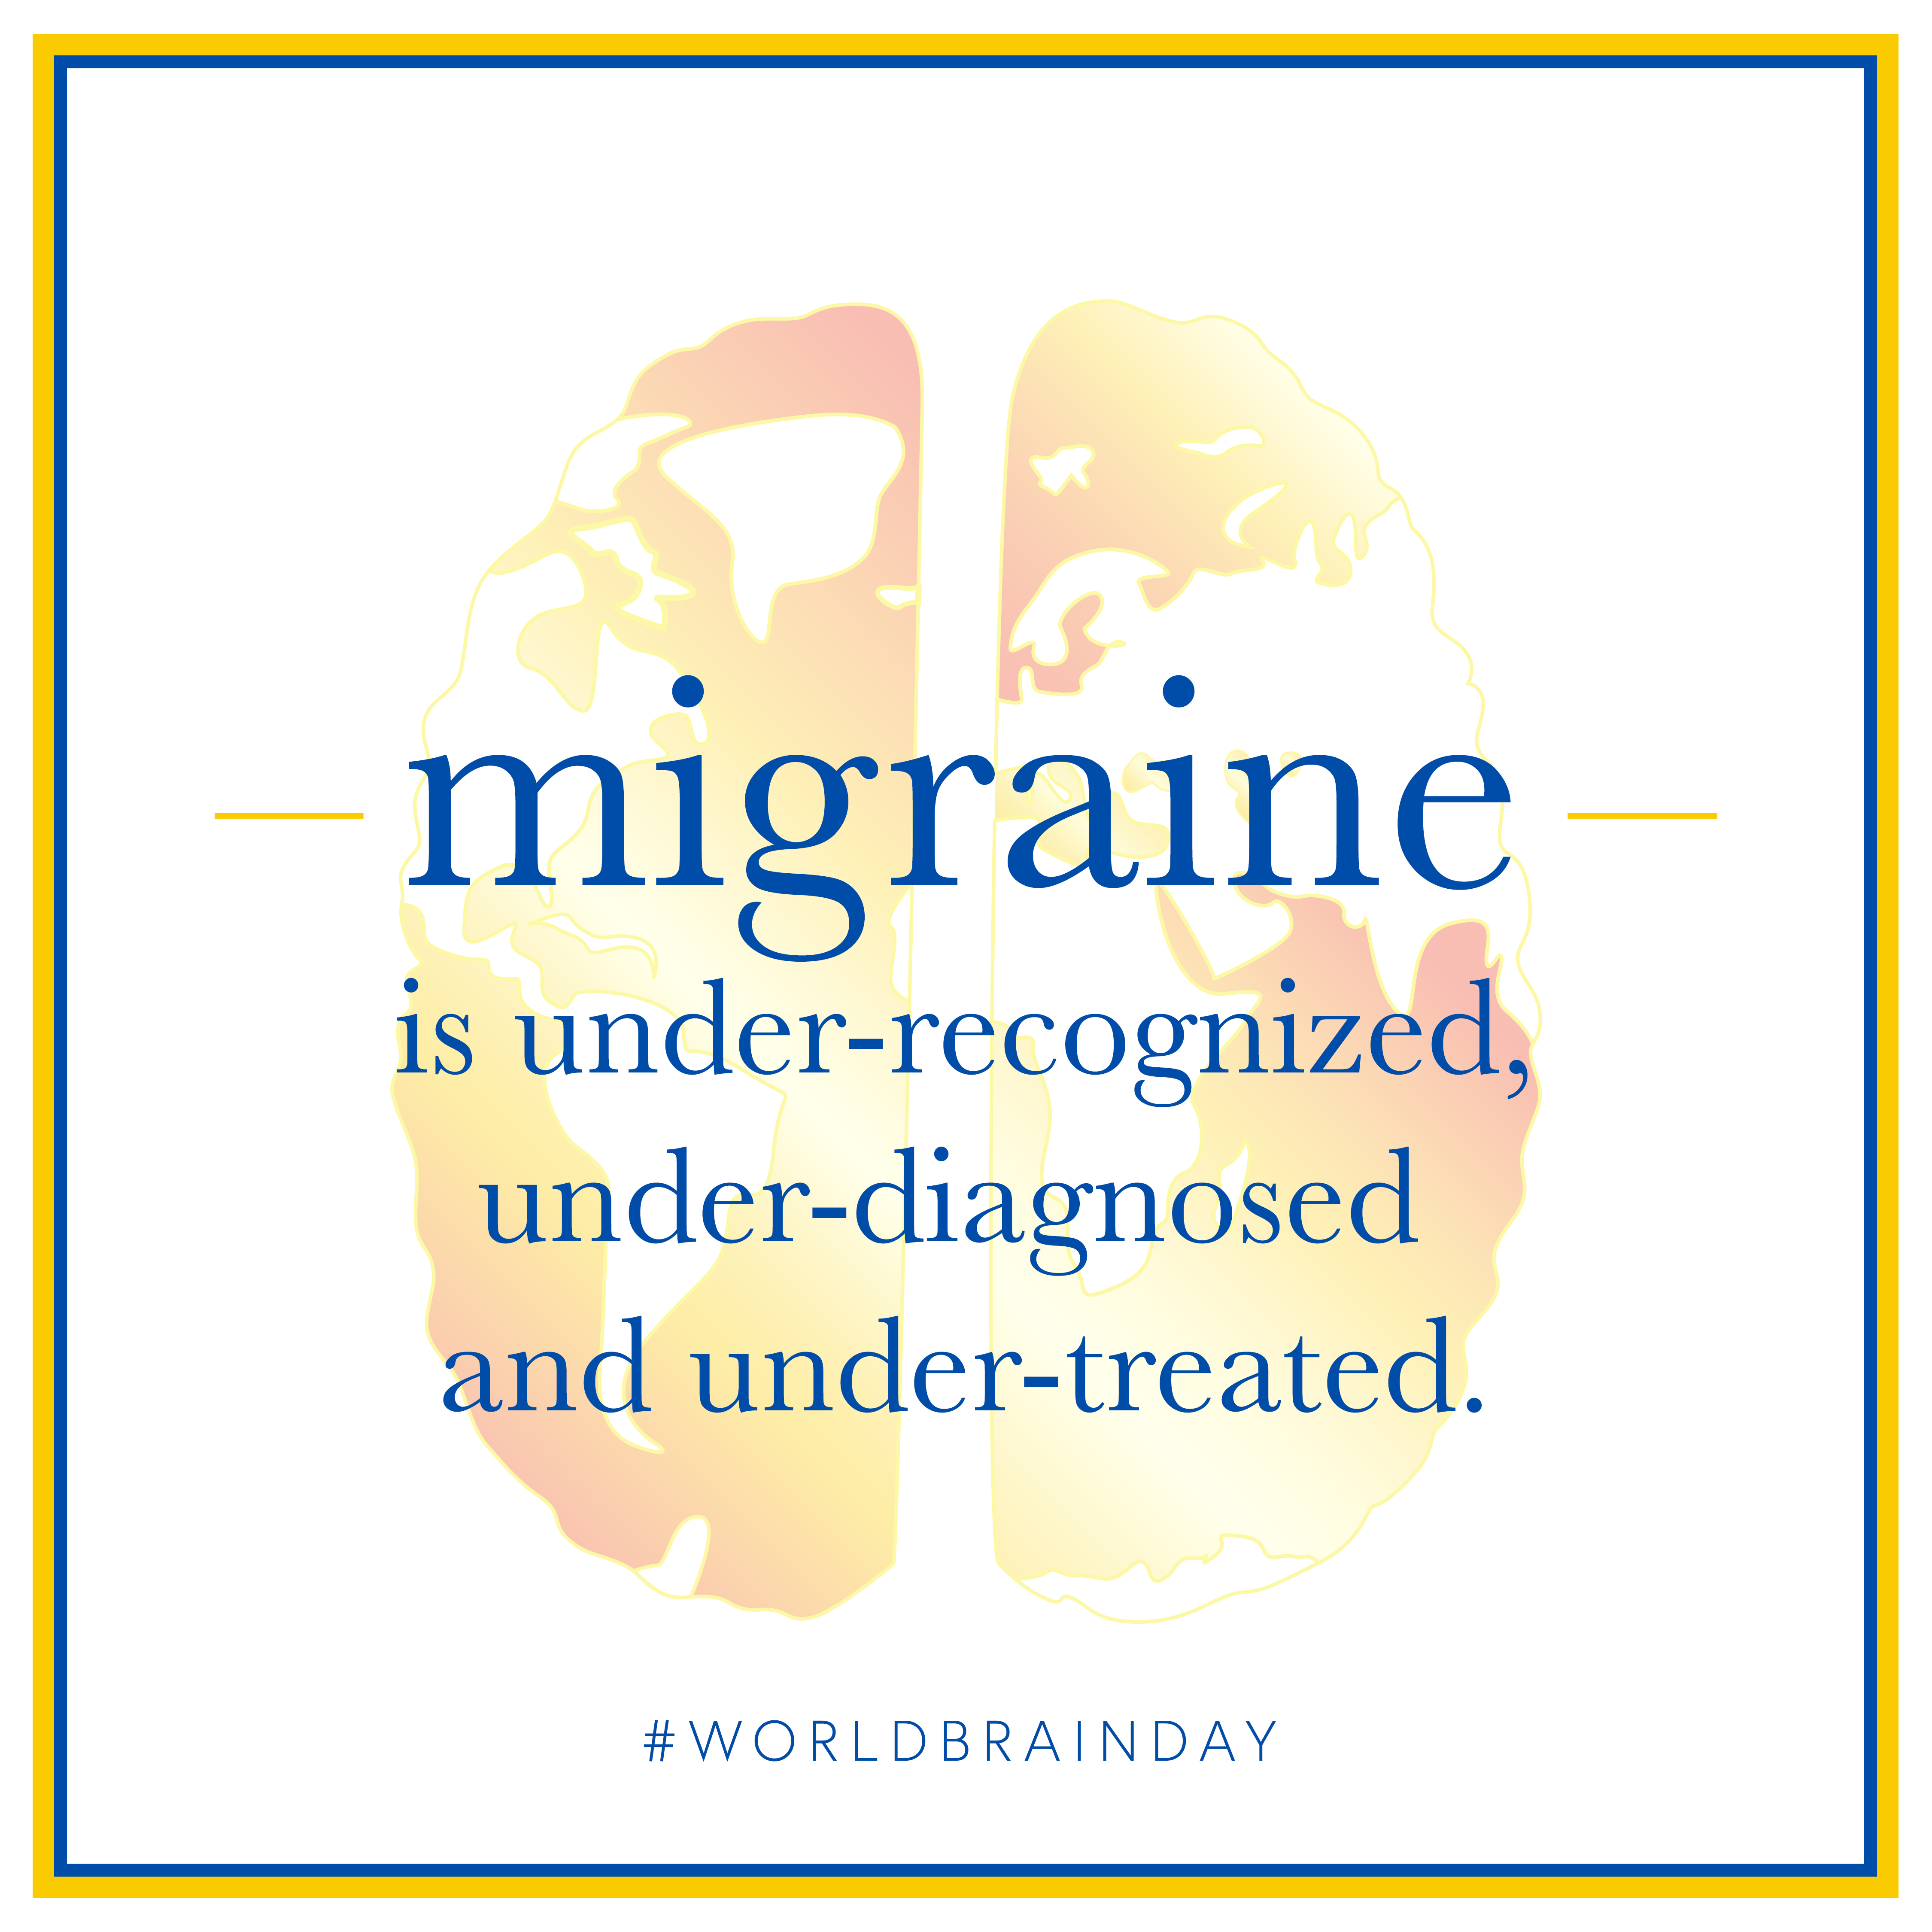
Monday, July 8 | Facebook/LinkedIn/Instagram:  Migraine is one of the leading causes of disability in the world and severely impacts every aspect of a person’s life. Despite the fact that #migraine affects one billion people around the globe, the painful truth is that migraine receives less research funding than all of the world’s most burdensome diseases. This year on World Brain Day, help us share vital information about migraine. Register to attend our July 22 webinar here. #worldbrainday  https://register.gotowebinar.com/register/4427363188472679693  Twitter:  The painful truth is that #migraine receives less research funding than all of the world’s most burdensome diseases. This year on #WorldBrainDay, help us share vital information about migraine. Register to attend our July 22 #webinar here.  https://register.gotowebinar.com/register/4427363188472679693 | 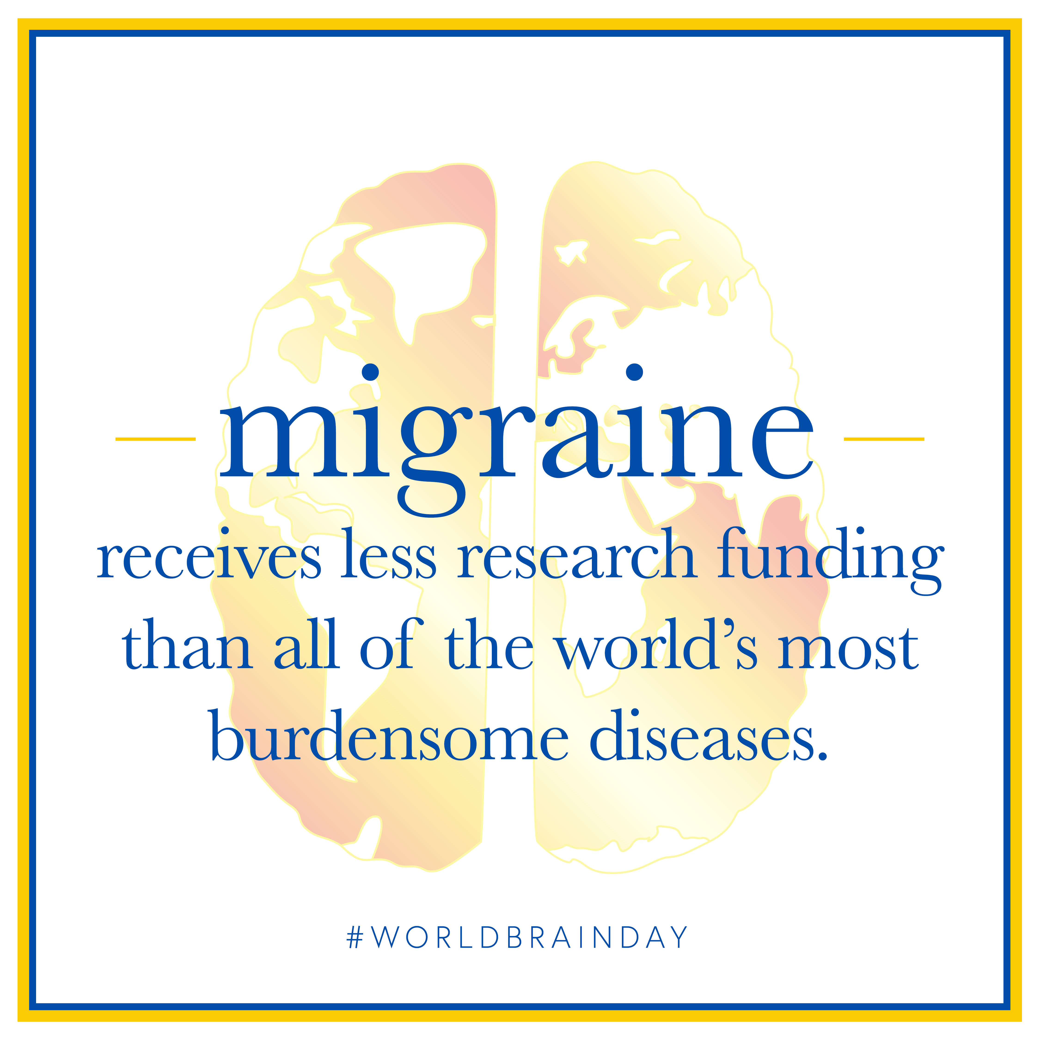
Monday, July 15 | Facebook/LinkedIn/Instagram:  This World Brain Day, share the painful truth to raise awareness around this debilitating disease to make sure those living with migraine get the help they need. Tell us how YOUR life would change if migraine had a cure. #WorldBrainDay #ThePainfulTruth  https://www.wfneurology.org/world-brain-day-2019  Twitter:  Let’s work together to make sure those living with #migraine get the help they need. This #WorldBrainDay, share #thepainfultruth–tell us how YOUR life would change if migraine had a cure.  https://www.wfneurology.org/world-brain-day-2019 | 