DATE | COPY | IMAGE
Share ASAP  Announcement Post  Save the Date 2020 | Facebook/LinkedIn:  On July 22, join the @World Federation of Neurology and the @International Parkinson and Movement Disorder Society as we move together to end Parkinson’s Disease.  This year, World Brain Day is dedicated to raising awareness for Parkinson’s Disease, a neurodegenerative brain disease that affects movement and almost all aspects of brain function. People with Parkinson’s disease may be particularly impacted by the current COVID-19 pandemic, further demonstrating the need for improved care and access.  Stay tuned for more information on how to help us stand together with the more than 7 million people living with PD worldwide.  https://wfneurology.org/world-brain-day-2020  Instagram:  On July 22, join the World Federation of Neurology and the International Parkinson and Movement Disorder Society as we move together to end Parkinson’s Disease.  This year, #WorldBrainDay is dedicated to raising awareness for #ParkinsonsDisease, a neurodegenerative brain disease that affects movement and almost all aspects of #brain function. People with Parkinson’s disease may be particularly impacted by the current #COVID19 pandemic, further demonstrating the need for improved care and access.  Stay tuned for more information on how to help us stand together with the more than 7 million people living with PD worldwide.  https://wfneurology.org/world-brain-day-2020  Twitter:  On July 22, join @wfneurology and @movedisorder as we move together to end Parkinson’s Disease, a neurodegenerative brain disease that affects movement and almost all aspects of #brain function. #worldbrainday https://wfneurology.org/world-brain-day-2020 | 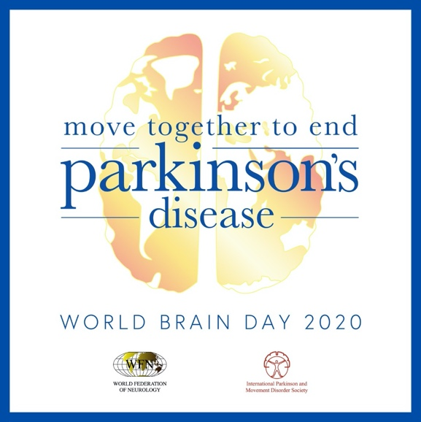
Monday, June 8  Post Theme: Prevalence  Fact #1 | Facebook/LinkedIn:  Parkinson’s Disease is a chronic, neurodegenerative brain disease that affects more than 7 million people of all ages worldwide—and its prevalence continues to increase. This #WorldBrainDay, download the #WBD2020 toolkit on our website and help us spread vital information about PD:  https://wfneurology.org/world-brain-day-2020  Instagram:  Parkinson’s Disease is a chronic, neurodegenerative brain disease that affects more than 7 million people of all ages worldwide—and its prevalence continues to increase. This #WorldBrainDay, download the #WBD2020 toolkit on our website and help us spread vital information about PD. Link in bio.  https://wfneurology.org/world-brain-day-2020  Twitter:  Parkinson’s Disease is a chronic, neurodegenerative brain disease that affects more than 7 million people of all ages worldwide—and its prevalence continues to increase. This #WorldBrainDay, download the #WBD2020 toolkit and help us spread PD facts:  https://wfneurology.org/world-brain-day-2020 | 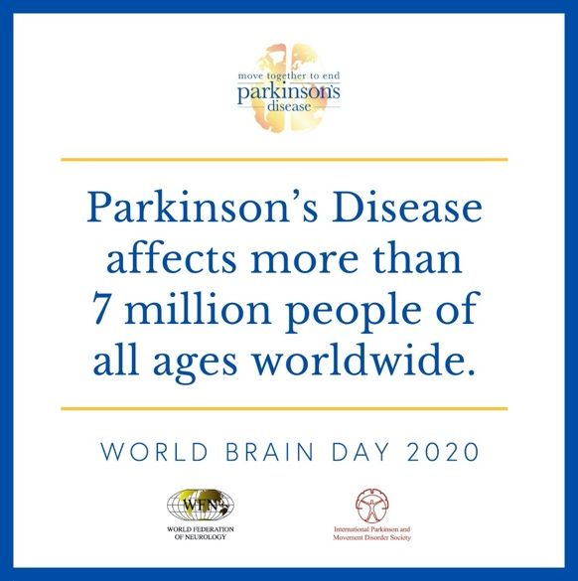
Monday, June 15  Post Theme: Promo Reminder  Promotional Post #1 | Facebook/LinkedIn:  On July 22, #WorldBrainDay honors those living with Parkinson’s Disease and their caregivers. The @World Federation of Neurology and the @International Parkinson and Movement Disorder Society are leading the global effort. See how you can participate:  Instagram:  On July 22, #WorldBrainDay honors those living with Parkinson’s Disease and their caregivers. The World Federation of Neurology and the International Parkinson and Movement Disorder Society are leading the global effort. See how you can participate by going to the World Federation of Neurology website.  Twitter:  On July 22, #WorldBrainDay honors those living with Parkinson’s Disease and their caregivers. The @wfneurology and the @movedisorder are leading the global effort. See how you can participate:  https://wfneurology.org/world-brain-day-2020 | 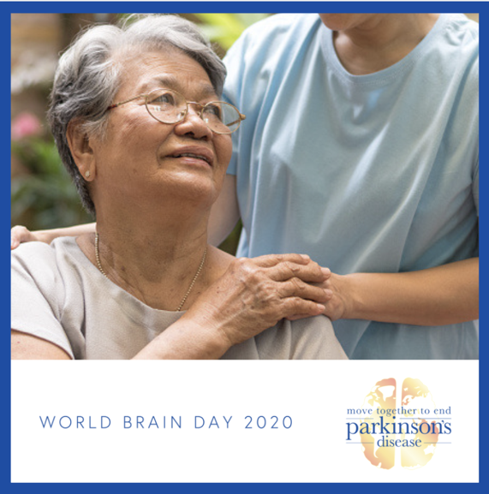
Monday, June 22  Post Theme: Disability  Fact #2 | Facebook/LinkedIn:  Parkinson’s Disease is not just shaking–it’s a disease that affects movement, impacts mood, disturbs sleep and more. Join us as we move together to end Parkinson’s Disease. Download the toolkit to help us raise awareness: #WorldBrainDay #WBD2020  https://wfneurology.org/world-brain-day-2020  Instagram:  Parkinson’s Disease is not just shaking–it’s a disease that affects movement, impacts mood, disturbs sleep and more. Join us as we move together to end Parkinson’s Disease. Download the toolkit to help us raise awareness. Link in bio. #WorldBrainDay #WBD2020  https://wfneurology.org/world-brain-day-2020  Twitter:  Parkinson’s Disease is not just shaking–it affects movement, impacts mood, disturbs sleep and more. Join us as we move together to end Parkinson’s Disease. Download the toolkit to help us raise awareness: #WorldBrainDay #WBD2020  https://wfneurology.org/world-brain-day-2020 | 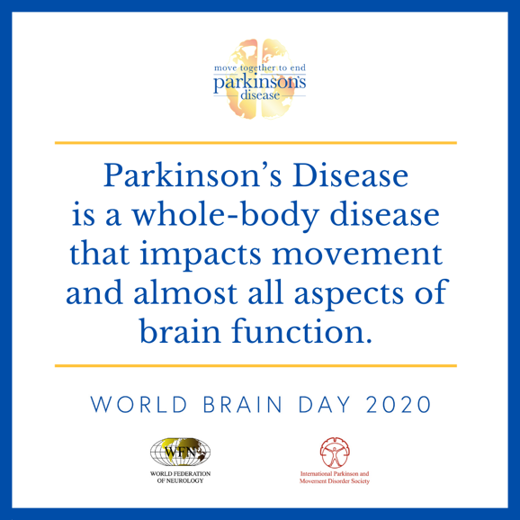
Monday, June 29  Post Theme: Standard of Care  Fact #3 | Facebook/LinkedIn:  Access to quality neurological care, life-changing treatments and essential medications are not available in many parts of the world. This #WorldBrainDay, we can move together to end Parkinson’s Disease. Download our free toolkit to help spread awareness:  https://wfneurology.org/world-brain-day-2020  Instagram:  Access to quality neurological care, life-changing treatments and essential medications are not available in many parts of the world. This #WorldBrainDay, we can move together to end Parkinson’s Disease. Download our free toolkit to help spread awareness. Link in bio.  https://wfneurology.org/world-brain-day-2020  Twitter:  Access to quality neurological care, life-changing treatments and essential medications are not available in many parts of the world. This #WorldBrainDay, we can move together to end Parkinson’s Disease. Download our free toolkit to help spread awareness:  https://wfneurology.org/world-brain-day-2020 | 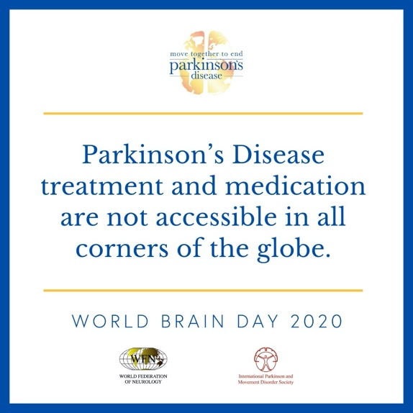
Monday, July 6  Post Theme: Promo Reminder  Promotional Post #2 | Facebook/LinkedIn:  Those impacted by Parkinson’s Disease may be particularly impacted by the current COVID-19 pandemic. #WorldBrainDay 2020 is dedicated to raising awareness to improve the lives of those with PD. See how you can make a difference on #WBD2020:  Instagram:  Those impacted by #ParkinsonsDisease may be particularly impacted by the current #COVID19 pandemic. #WorldBrainDay 2020 is dedicated to raising awareness to improve the lives of those with PD. See how you can make a difference on #WBD2020 by visiting the World Federation of Neurology’s website.  Twitter:  Those impacted by #ParkinsonsDisease may be particularly impacted by the current #COVID19 pandemic. #WorldBrainDay 2020 is dedicated to raising awareness to improve the lives of those with PD. See how you can make a difference on #WBD2020:  https://wfneurology.org/world-brain-day-2020 | 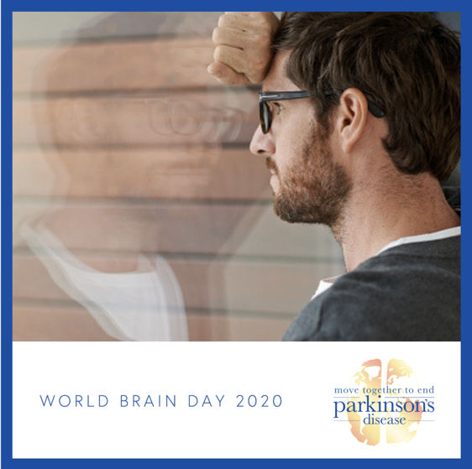
Monday, July 13  Post Theme: Research  Fact #4 | Facebook/LinkedIn:  Even though over 7 million people live with Parkinson’s Disease worldwide, the cause is still unknown and there is no cure. Join us July 22 on #WorldBrainDay to bring more attention to this disease:  https://wfneurology.org/world-brain-day-2020  Instagram:  Even though over 7 million people live with Parkinson’s Disease worldwide, the cause is still unknown and there is no cure. Join us July 22 on #WorldBrainDay to bring more attention to this disease. Link in bio.  https://wfneurology.org/world-brain-day-2020  Twitter:  Even though over 7 million people live with Parkinson’s Disease worldwide, the cause is still unknown and there is no cure. Join us July 22 on #WorldBrainDay to bring more attention to this disease:  https://wfneurology.org/world-brain-day-2020 | 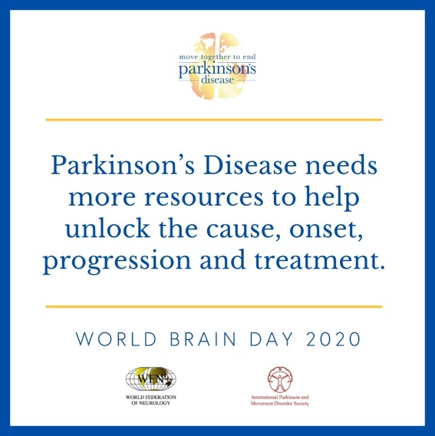
Wednesday, July 15, 2020  Post Theme: Advocacy  Fact #5 | Facebook/LinkedIn:  This #WorldBrainDay, let’s move together to end Parkinson’s Disease. Tell us how YOUR life would change if PD had a cure. #WBD2020  Instagram:  This #WorldBrainDay, let’s move together to end Parkinson’s Disease. Tell us how YOUR life would change if PD had a cure. #WBD2020  Twitter:  This #WorldBrainDay, let’s move together to end Parkinson’s Disease. Tell us how YOUR life would change if PD had a cure. #WBD2020 | 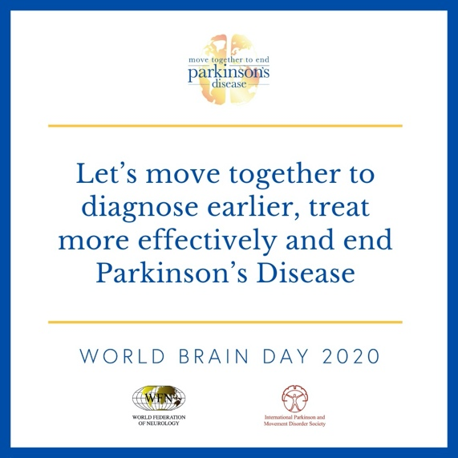
Monday, July 20, 2020  Post Theme: Promo Reminder  Promotional Post #3 | Facebook/LinkedIn:  Join the voices of more than 126 global organizations this #WorldBrainDay as we come together to end Parkinson’s Disease. Share how your life would be different without this brain disease in the comments!  Instagram:  Join the voices of more than 126 global organizations this #WorldBrainDay as we come together to end Parkinson’s Disease. Share how your life would be different without this brain disease in the comments!  Twitter:  Join the voices of more than 126 global organizations this #WorldBrainDay as we come together to end Parkinson’s Disease. Share how your life would be different without this brain disease in the replies!  https://wfneurology.org/world-brain-day-2020 | 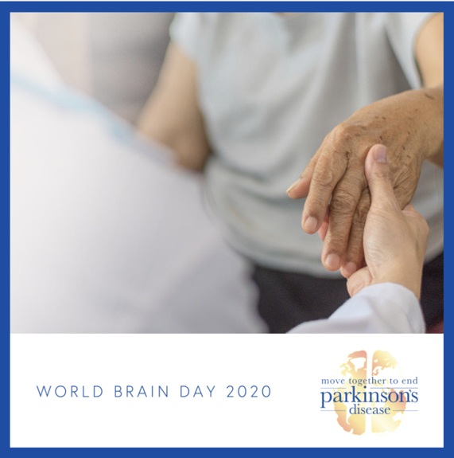
Wednesday, July 22, 2020  Post Theme: WBD2020 | Facebook/LinkedIn:  Today is #WorldBrainDay 2020 and we are dedicated to raising awareness for Parkinson’s Disease. We stand with over 7 million people living with this disease and their caregivers because we know PD’s impact. Let’s move together to end Parkinson’s DIsease! #WBD2020  Instagram:  Today is #WorldBrainDay 2020 and we are dedicated to raising awareness for Parkinson’s Disease. We stand with over 7 million people living with this disease and their caregivers because we know PD’s impact. Let’s move together to end Parkinson’s DIsease! #WBD2020  Twitter:  Today is #WorldBrainDay 2020 and we are dedicated to raising awareness for Parkinson’s Disease. We stand with over 7 million people living with this disease and their caregivers because we know PD’s impact. Let’s move together to end Parkinson’s DIsease! #WBD2020 | 